**Task 9: Shell Scripting**

**Submitted by: 160115733122**

**Question 1**

(a)

#!/bin/bash

fcount=0

for i in $(ls); do

let count=$(($fcount + 1))

done

echo "Number of files: $count"



(b)

#!/bin/bash

count=0

if [ $# -eq 1 ]

then

path=$1

cd $path

for i in $(ls); do

let count=$(($count + 1))

done

echo "Number of files: $count"

fi

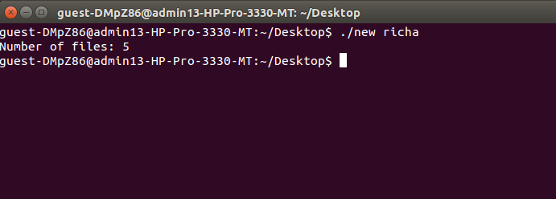

(c)

#!/bin/bash

count=0

if [ $# -eq 1 ]

then

path=$1

cd $path

for i in $(ls); do

let count=$(($count + 1))

done

echo "Number of files: $count"

else

echo "Correct usage: ./script_name PATH"

fi

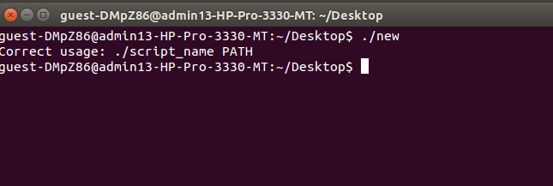

**Question 2**

(a)

#!/bin/sh

file="$1"

echo $(stat --format "%A" $file)

echo $(stat --format "%h" $file)

echo $(stat --format "%G" $file)

echo $(stat --format "%U" $file)

echo $(stat --format "%s" $file)

echo $(stat --format "%z" $file)

echo "$1"

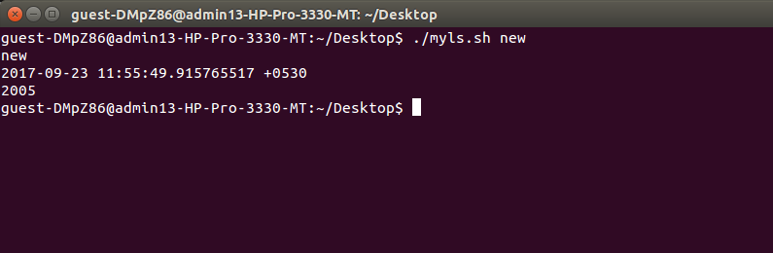

(b)

#!/bin/sh

file="$1"

echo "$1"

echo $(stat --format "%z" $file)

echo $(stat --format "%s" $file)



**Question 3**

(a)

#!/bin/bash

if [ "$1" = "y" ] || [ "$1" = "Y" ] || [ "$1" = "yes" ] || [ "$1" = "YES" ]

then

exit 0

else

exit 1

fi

(b)

#!/bin/bash

if [ "$#" -gt "0" ]

then

arg1="$(echo $1 | tr a-z A-Z)"

if [ "$arg1" = "Y" ] || [ "$arg1" = "YES" ]

then

echo "$arg1"

exit 0

else

exit 1

fi

else

exit 1

fi

**Question 4**

#!/bin/bash

size=0

fsize=0

for i in $(ls); do

##let file=i

let fsize=$(stat --format "%s" $i)

let size=$(($size + $fsize))

done

echo "Total size: $size"

